**1. INTRODUCTION:**

**1.1 OVERVIEW:**

Fresh Bites Catering, a catering service, utilizes Zoho books to manage sales, track inventory, and handle invoicing. They can generate professional invoices for clients and track expenses related to ingredients and supplies. Zoho books help them maintain accurate financial records and streamline their catering operations.

**1.2 PURPOSE:**

Zoho books' clean and simple dashboard gives you immediate, convenient insight into your financial health. An effective, user-friendly UI makes Zoho books easy to navigate. And also its have lots of features; It helps to,

* Item creation
* create GSTR-3B
* Banking transactions
* To create purchase order
* Purchase order to bills conversion
* Purchase bills creation
* Creation of vendor
* Payment made to the vendor
* Creation of customer
* To create a sales order
* Sales order to invoice conversion
* Create invoices
* Receipt making invoices
* To record small expenses
* To create Financial reports

1. Balance sheet
2. Profit and loss.

**2.problem definition & Design thinking**

**2.1 Empathy Map**

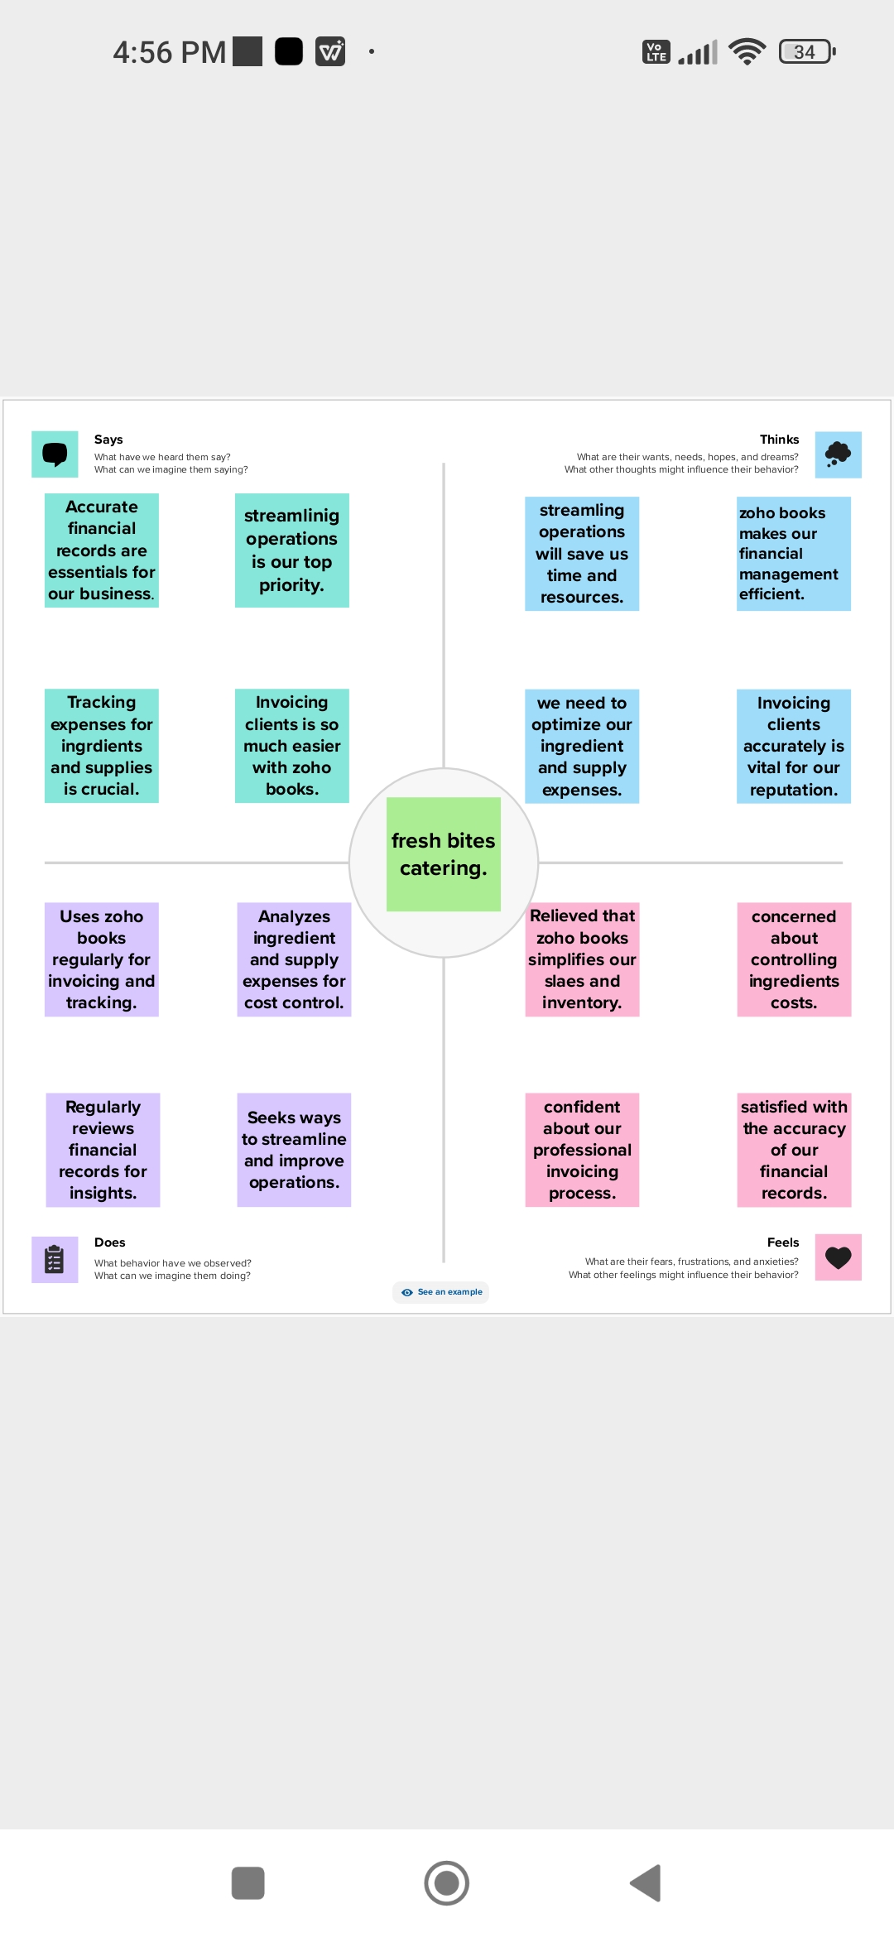

* 1. **ideation ana brainstorming map**

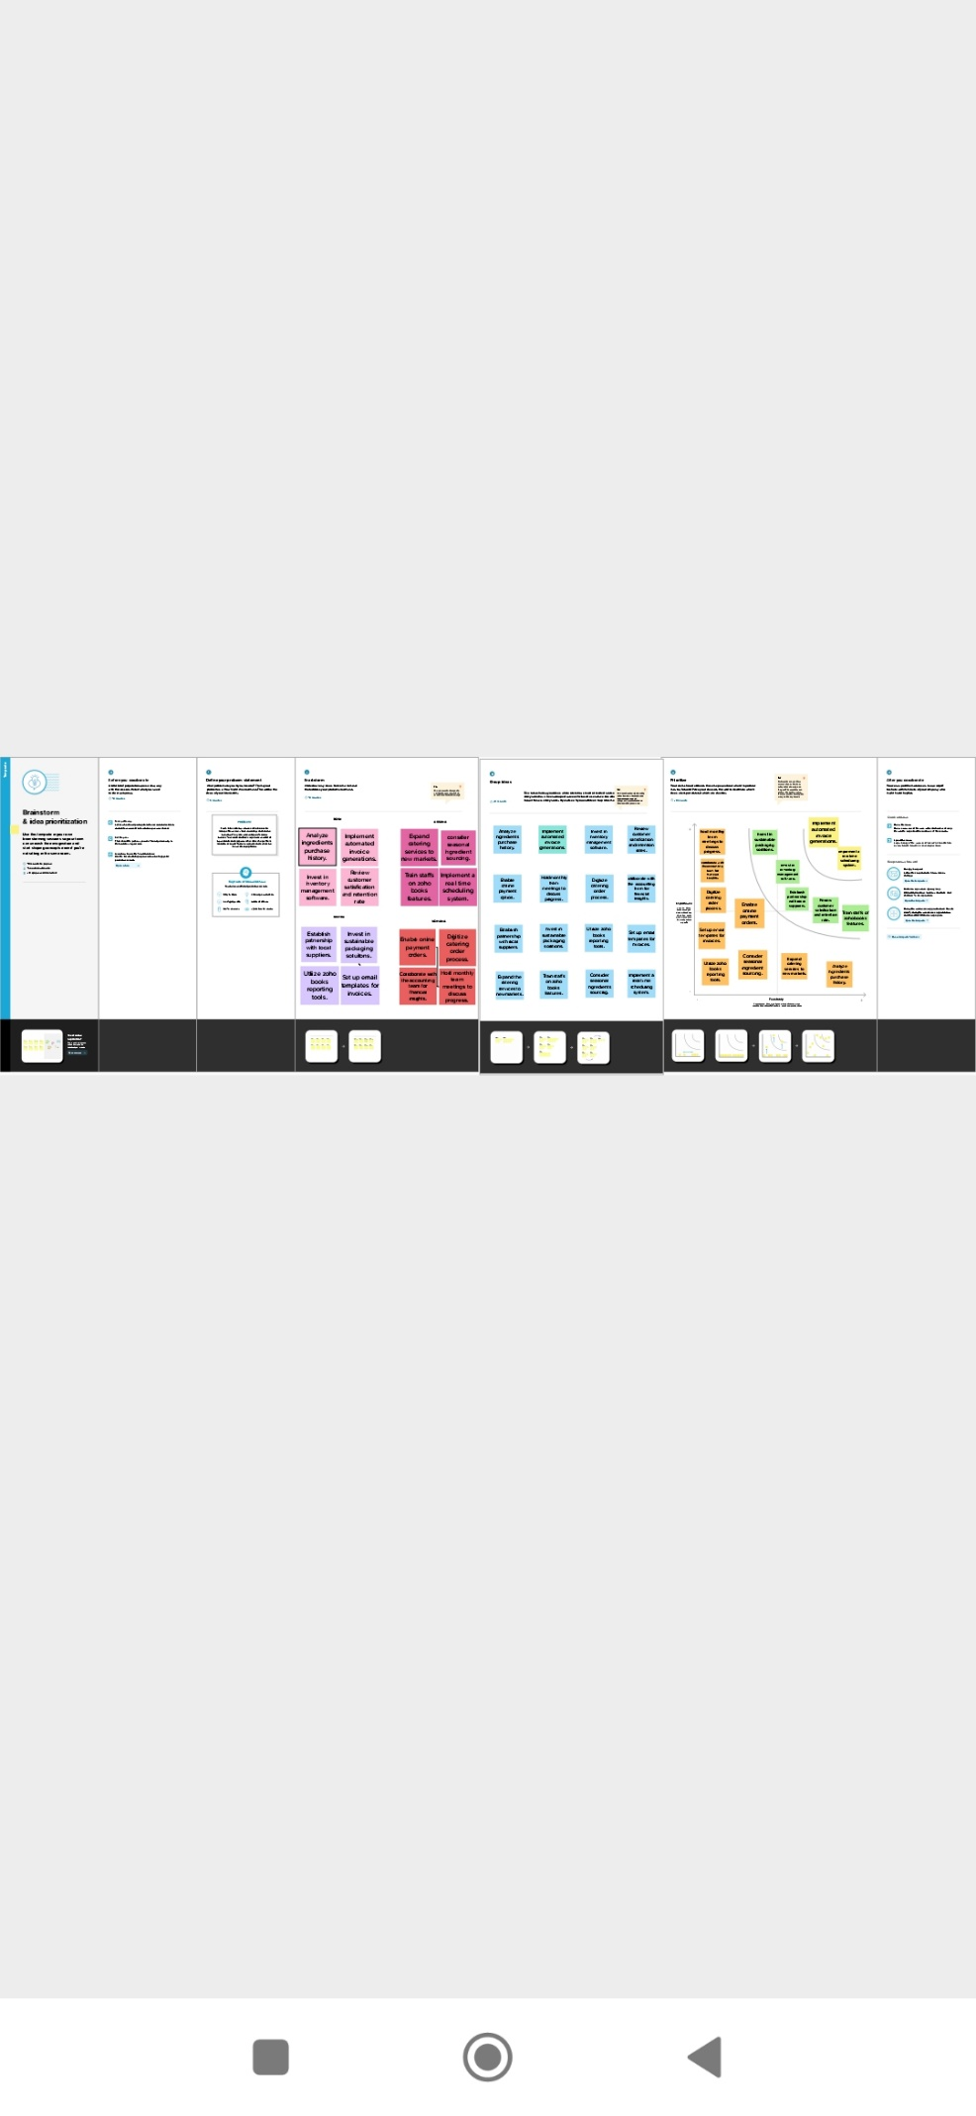

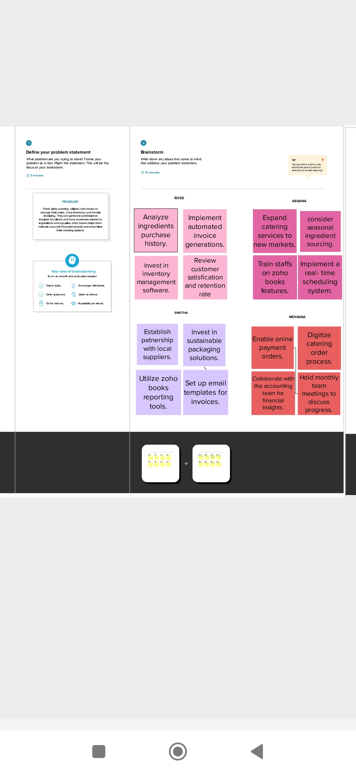

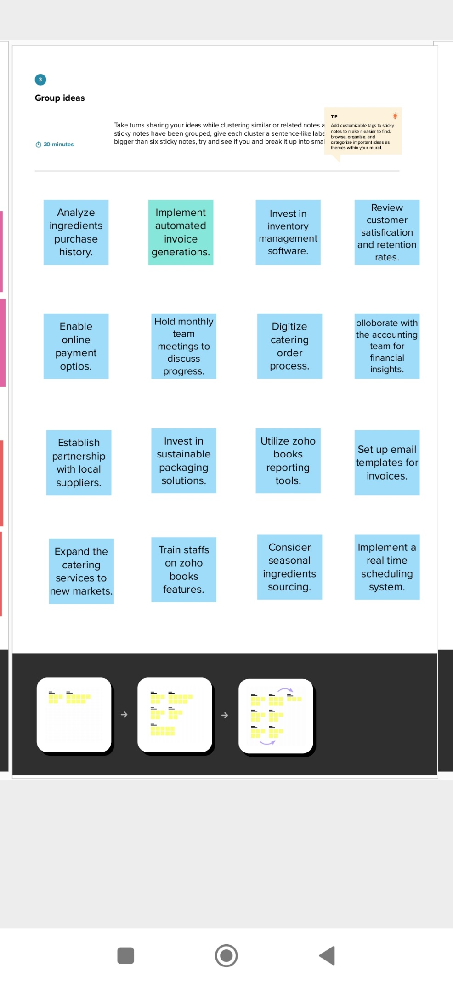

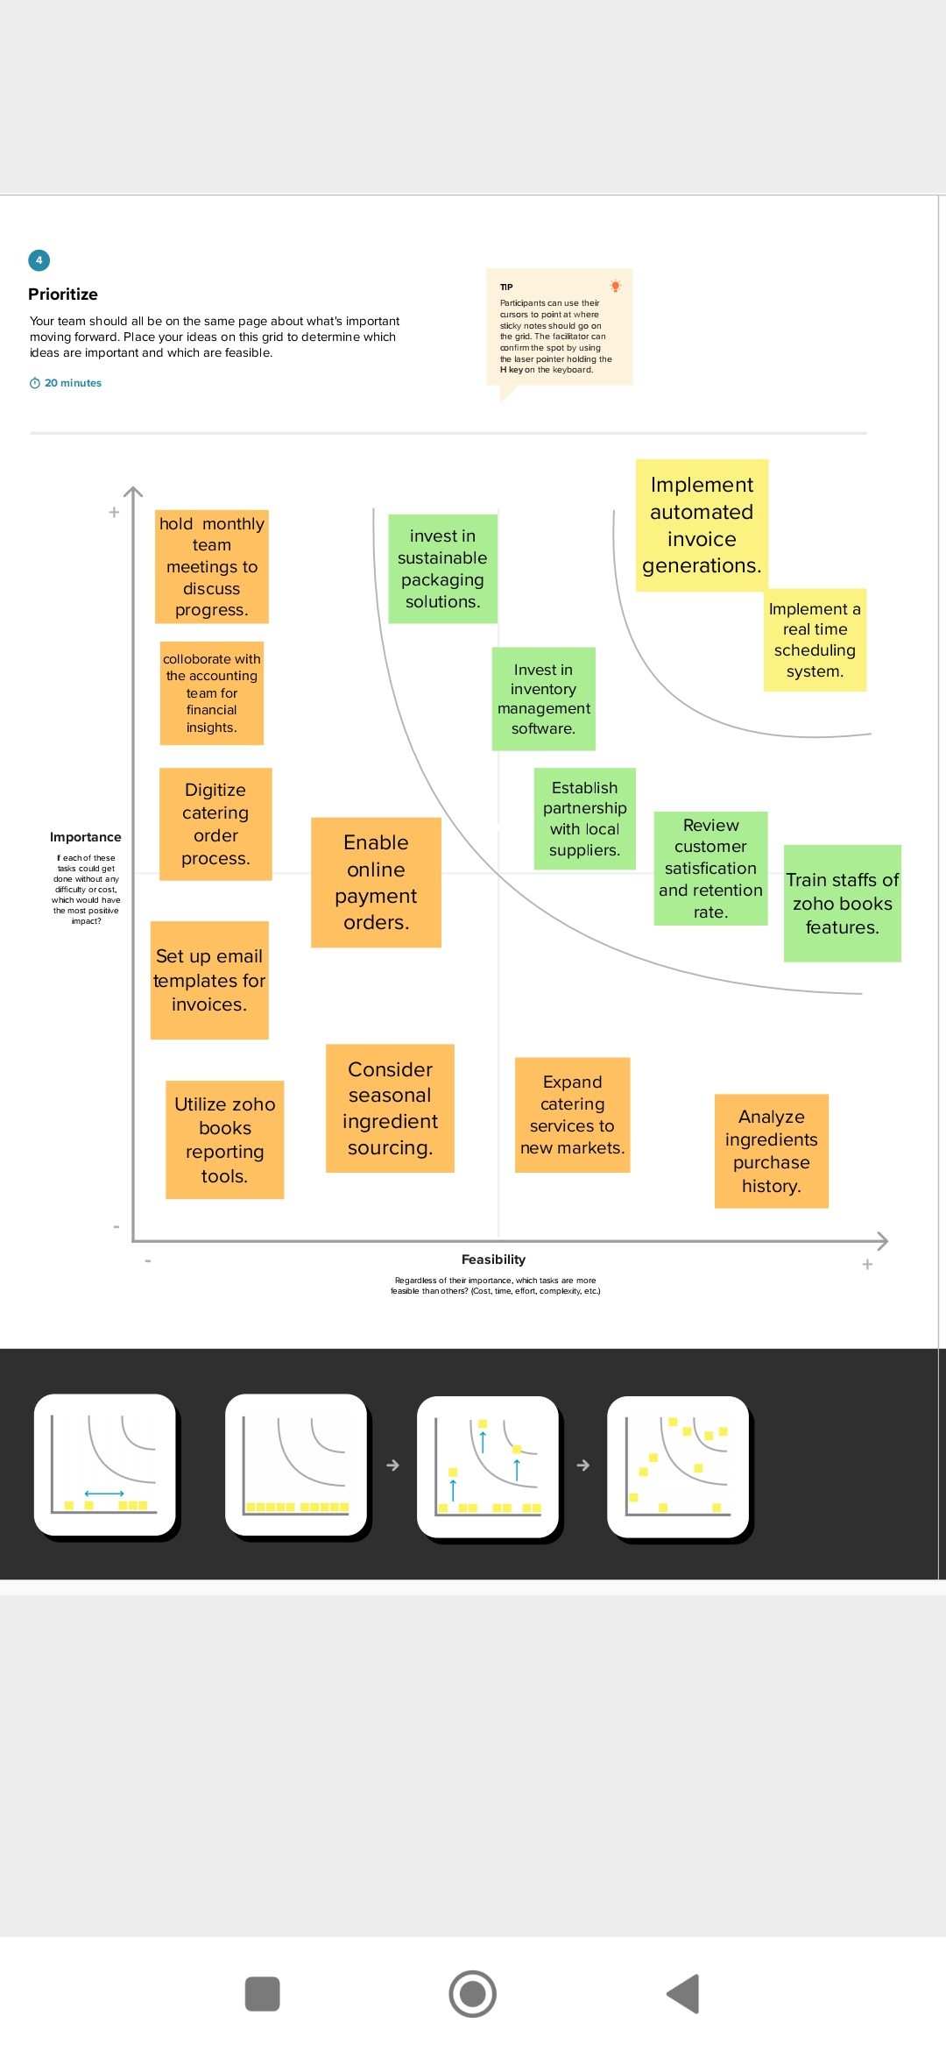

**3.RESULTS:**

**PROFIT AND LOSS ACCOUNT:**

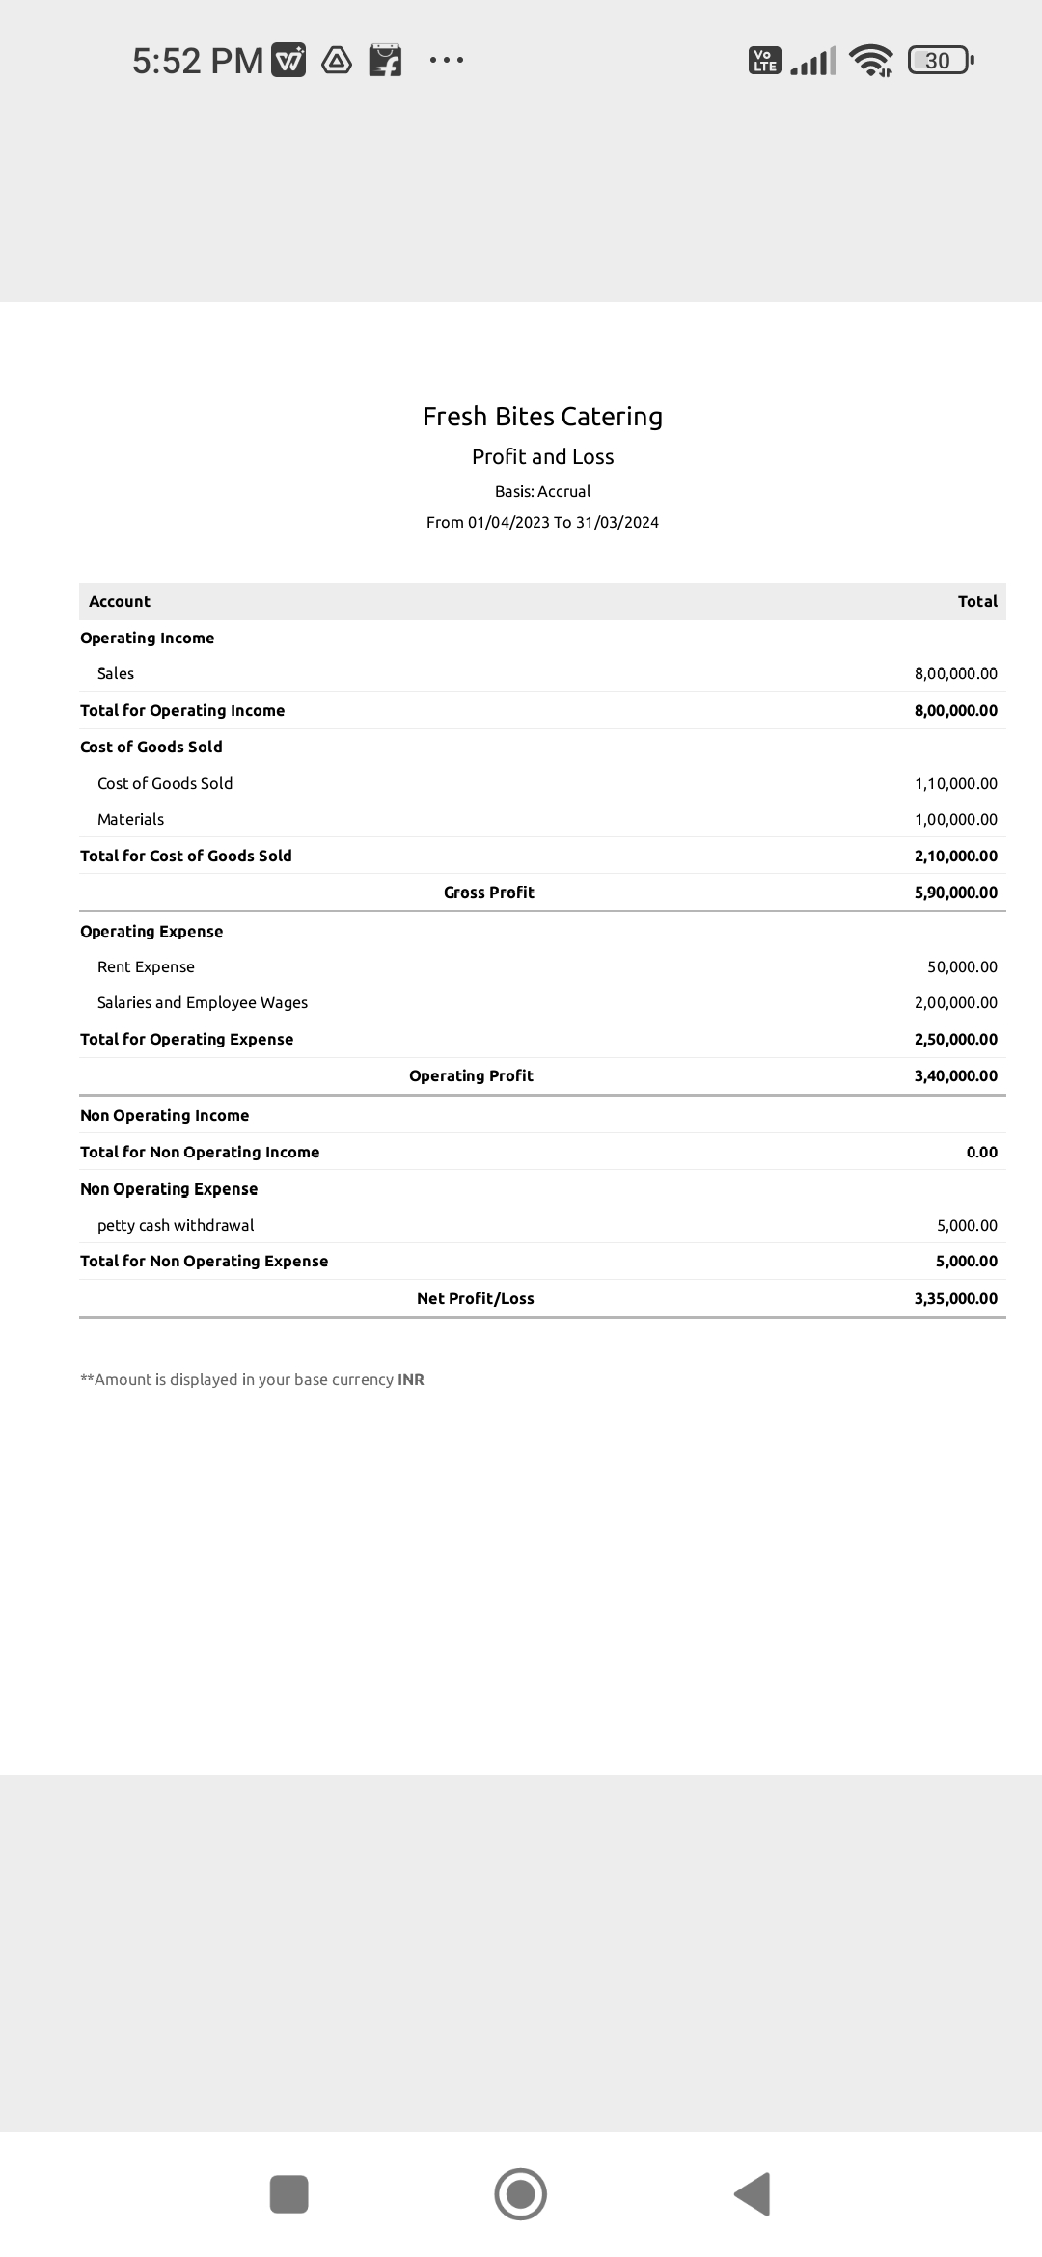

**BALANCE SHEET:**

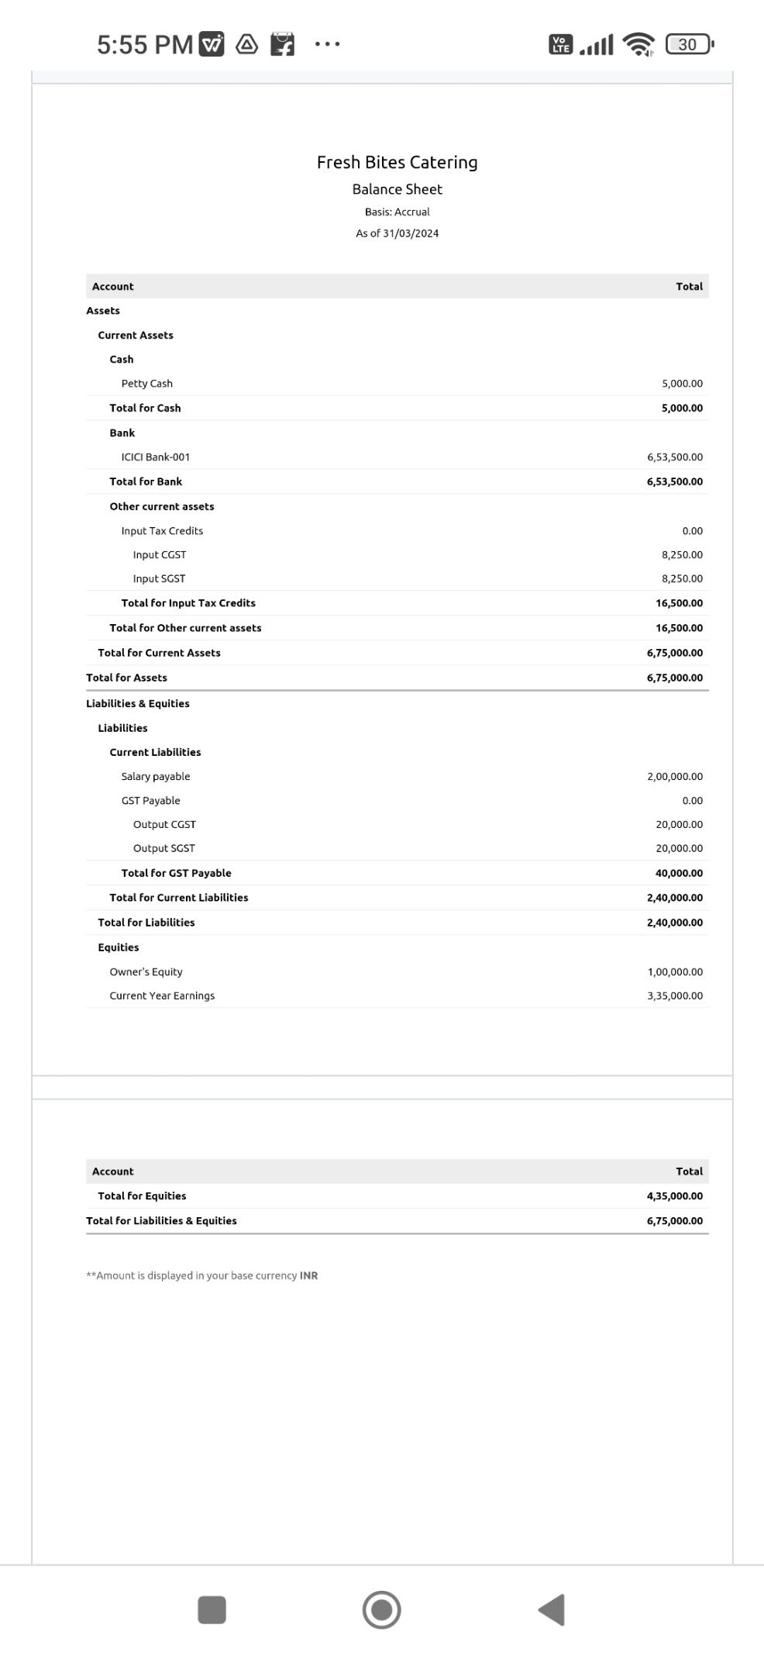

SEE IT IS EASY TO PREPARE THE FINAL ACCOUNTS OF OUR FRESH BITES CATERING WITHOUT ANY NEGLIGENCE. IT IS A CLOUD BASED SOFTWARE SO WE CAN USE IT **ANYTIME AT ANYWHERE.**

**4. ADVANTAGES AND DISADVANTAGES**

**ADVANTAGES:**

* INVOICING AND BILLING
* ONLINE PAYMENTS
* EXPENSE TRACKING
* INVENTORY MANAGEMENT
* BANK RECONCILIATION
* PROJECT MANAGEMENT AND TIME MANAGEMENT
* REPORT GENERATION
* REDUCE OVERALL COSTS
* MINIMIZES DATA LOST

**DISADVANTAGES:**

* ZOHO REQUIRES CODING ABILITIES TO MAKE THE MOST OF ITS AUTOMATION FEATURES, WHICH MAY BE CHALLENGING FOR BUSINESS OWNERS WHO ARE NOT TECH-SAVVY.
* THE GAP IN THE NUMBER OF MONTHLY TRANSACTIONS AND USERS MAY DISSUADE HIGH-VOLUME, EMPLOYEE-HEAVY BUSINESS FROM USING THE SOFTWARE.

**5.APPLICATIONS:**

* AFFORDABLE PRICING PLANS
* SECURITY
* MANAGE DOCUMENT SEAMLESSLY
* RELIABILITY
* EFFORTLESS SETUP AND IMPORT
* CUSTOMISE YOUR TEMPLATE

**6. CONCLUSION:**

FRESH BITES CATERING IS A WELL-GOING BUSINESS. WE SELL ALL THE FOODS WITH LOVE AND AFFORDABLE PRICE. WE USE ZOHO BOOKS TO MAINTAIN OUR ACCOUNTS. WE ENTER EVERY TRANSACTION AND MAKE PAYMENTS TO VENDORS WITHOUT ANY DELAY. IT IS ALSO IN CURRENT TREND SO WE DON’T CARE ABOUT THE GST AND OTHER CURRENT TAXES. WE ALSO DO THE TRANSACTIONS AT **ANY TIME ANYWHERE.**

**7. FUTURE SCOPE:**

ZOHO BOOKS HAS MANY FEATURES IT WILL TELL US HOW THE FUTURE IS

* YOU CAN NOW APPLY TCS IN VENDOR CREDIT TRANSACTIONS.
* WE NOW HAVE A DEDICATED TAB FOR ANNOUNCEMENTS FROM ZOHO BOOKS SO YOU DON’T MISS OUT ON ANY IMPORTANT NEWS ABOUT EVENTS, UPDATES OF OUR CATERING SERVICE
* DISASSOCIATE SALES ORDERS FROM VOID INVOICES
* INTRODUCING SIGNALS
* PURCHASE BY CATEGORY REPORTS